**NEWS TRACKER APPLICATION USING CLOUD**

**TEAM ID-PNT2022TMID12566**

**ABSTRACT**

Everyone is guaranteed the right to free speech. However, in the guise of free expression, this privilege is being abused to discriminate against and harm other people. ThisHate speech is another name for discrimination. A clear definition of hate speech is language that expresses hatred for an individual or a group of individuals based on traits including race, religion, ethnicity, gender, nationality, handicap, and sexual orientation.

Humanity has benefited greatly from the expanding usage of social media and knowledge sharing. However, this has also led to a variety of problems, including the spreading and distributing of hate speech messages. Thus, recent studies used a range of machine learning and deep learning techniques with text mining methods to automatically recognise the hate speech messages on real-time datasets in order to address this developing issue in social media sites. There are many benefits for humanity through the use of social media and information sharing that is on the rise. But it has also led to a variety of problems, such as the spreading and distribution of hate speech. Thus, recent studies used a variety of machine learning and deep learning techniques along with text mining algorithms to automatically recognise hate speech messages on real-time datasets in order to address this emerging issuein social media sites.

**TABLE OF FIGURES**

**1. INTRODUCTION**

1.1.Problem Statement

1.2. Project Overview

1.3. Purpose

**2. LITERATURE SURVEY**

2.1 Existing problem

2.2 References

**3. IDEATION & PROPOSED SOLUTION**

3.1 Empathy Map Canvas

3.2 Ideation & Brainstorming

3.3 Proposed Solution

3.4 Problem Solution fit

**4. REQUIREMENT ANALYSIS**

4.1 Functional requirement

4.2 Non-Functional requirements

**5. PROJECT DESIGN**

5.1 Data Flow Diagrams

5.2 Solution & Technical Architecture

5.3 User Stories

**6. PROJECT PLANNING & SCHEDULING**

6.1 Sprint Planning & Estimation

6.2 Sprint Delivery Schedule

6.3 Reports from JIRA

**7. CODING & SOLUTIONING**

7.1 Signup/Registration

7.2 Login

7.3. Dashboard

7.4.Logout

7.5.Database Schema (if Applicable)

**8. TESTING**

8.1 Test Cases

8.2 User Acceptance Testing

**9. RESULTS**

9.1 Performance Metrics

**10. ADVANTAGES & DISADVANTAGES**

**11. CONCLUSION**

**12. FUTURE SCOPE**

**13. APPENDIX**

**INTRODUCTION:**

Ecosystems of mobile apps are changing how people consume news. In the past, reading the news was primarily reserved for users who were "on the go"; but, today, two out of every three mobile device users in the US regularly access the news, and up to one in five read in-depth news articles every day [2]; a similar picture is observed in the UK [1]. The shift of news consumers to the Internet is being continued by this increase in mobile news access.

**1.1.Problem Statement**

Reading the newspaper has become one of the classic ways to read the news in today's busy society. The revised news is already outdated the next morning because it is produced every minute and distributed by TV, radio, and the internet. People are enthralled by smartphones and other mobile devices in this digital age. They demand access to all necessary information at their fingertips.

**1.2. Project overview**

The necessity for customizing news app interactions is clear as more people consume news on smartphones and tablets. We provide findings from three experiments that focus on crucial challenges in the design of adaptive news app interfaces. We started by asking people about their reading habits and interests, and our analysis identified three main categories of readers. After that, we developed and released an Android news app that keeps track of user interactions. We demonstrated that a classifier we trained using the logs can accurately identify a user based on the type of reader they are. Finally, we assessed various adaptive user interfaces for every type of reader. The review shows how different users of the news app will benefit from the modification differently, and it also shows that adaptive interfaces are feasible.

**1.2 Purpose**

We frequently feel that we need more than 24 hours a day to do everything on our calendar because our lives are so hectic these days. That's not realistic, but you can cut down on the time by reading the news differently than you usually do. Simply let us know what market news you're interested in to receive a daily sneak glance. Save time by reading only the content you choose to be pertinent. With the aid of this software, you may search for all available data on indices, commodities, currencies, future rates, bonds, etc., just as on reputable websites.

**2. LITERATURE SURVEY**

**2.1 Existing problem**

We frequently believe that there aren't enough hours in the day to get everything done. That's not realistic, but you can cut down on the time by reading the news differently than you usually do.

**2.2 References**

Like articles, websites, blogs. https://www.researchgate.net/. https://techvidvan.com/tutorials/android-news-app-project-source-code/ https://www.ripublication.com/

3. IDEATION & PROPOSED SOLUTION

3.1 Empathy Map Canvas

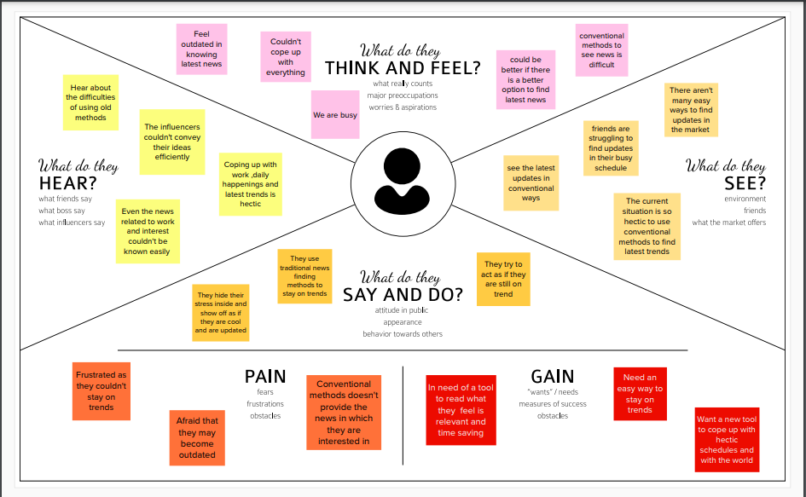

3.2 Ideation & Brainstorming

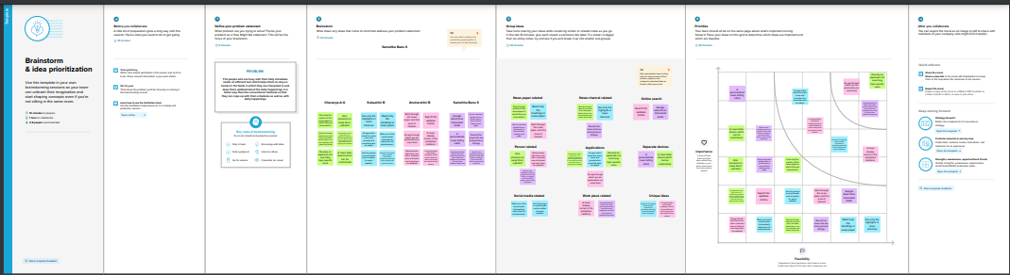

**3.3 Proposed Solution :**

|  |  |  |
| --- | --- | --- |
| **S.No.** | **Parameter** | **Description** |
| 1. | Problem Statement (Problem to be solved) | To develop an application that helps to track day-to-day news. |
| 2. | Idea / Solution description | The main focus of this application is to connect news articles from all around the world and deliver it to users as fast as possible in the best visualized way. |
| 3. | Novelty / Uniqueness | A customizable informative wallpaper which shows different news every time we switch on the phone |
| 4. | Social Impact / Customer Satisfaction | This application helps each reader to understand the news on a daily basis in a way that’s personally meaningful to them. It can help a reader understand their personal connection to a broad national phenomenon, and help them attach what they know to what they don’t know, and thereby encourage a deep understanding of historical and current events. |
| 5. | Business Model (Revenue Model) | A resource which is a special TV program which quickly summarizes everything including news of the daily happening events especially for the people with hectic schedules. |
| 6. | Scalability of the Solution | The developer will have the privilege to extend the functionalities of the application even after the deployment of the application. |

**PROBLEM SOLUTION FIT**

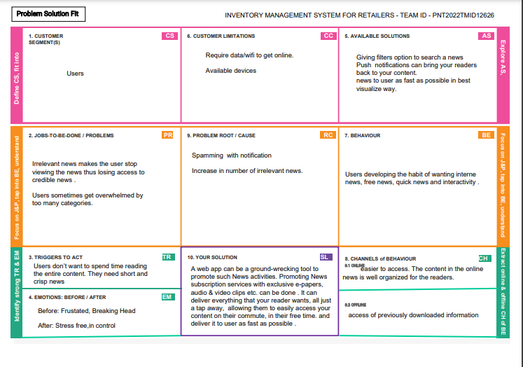

**4. REQUIREMENT ANALYSIS**

**4.1.Functional Requirements:**

|  |  |  |
| --- | --- | --- |
| FR No. | Functional Requirement (Epic) | Sub Requirement (Story / Sub-Task) |
| FR-1 | User Registration | Registration through Form Registration through Gmail Registration through LinkedIN |
| FR-2 | User Confirmation | Confirmation via Email Confirmation via OTP |
| FR-3 | Filter Option | The user can filter the news based on their  interests by using the filter option. |
| FR-4 | Search Option | The user has the ability to look for news  pertaining to a specific topic using the search option. |
| FR-5 | All news feed displayed | The user will see the most recent news that was fetched from the API. |
| FR-6 | Edit Profile | When necessary, the user may modify the  information in their profile. |
| FR-7 | Language Based | Depending on the user's interests, the language of the news that is displayed to them can be altered. |

**4.2.Non-functional Requirements:**

5.Following are the non-functional requirements of the proposed solution.

|  |  |  |
| --- | --- | --- |
| **FR No.** | **Non- Functional**  **Requirement** | **Description** |
| NFR-1 | **Usability** | The UI should be accessible for everyone irrespective of their details like location, language, Interest etc. User should have the flexibility of using the application in any of the devices. Despite of the device the content should be delivered in the correct way |
| NFR-2 | **Security** | Only the Authorized users can access the system with their credentials.  And no others can able to access the application other than them. |

|  |  |  |
| --- | --- | --- |
| NFR-3 | **Reliability** | The priority for breaking news should be displayed according to their location is first. If it is not available or cannot able to display it then other news should be displayed. That is some kind of news should always be displayed to the user whenever they use the application. The recovery of the application should be immediate such that the downtime of the application should be negligible. |
| NFR-4 | **Performance** | The performance of the system should be reliable with high-end servers on which the software is running. |
| NFR-5 | **Availability** | The application should be available to all kind of authorized users all the time. Even when the application needs to be updated the existing modules and their functionalities should be available to the users. |
| NFR-6 | **Scalability** | The whole software deployed must be easily scalable as the customer base increases. |

**5. PROJECT DESIGN**

**5.1 Data Flow Diagrams**

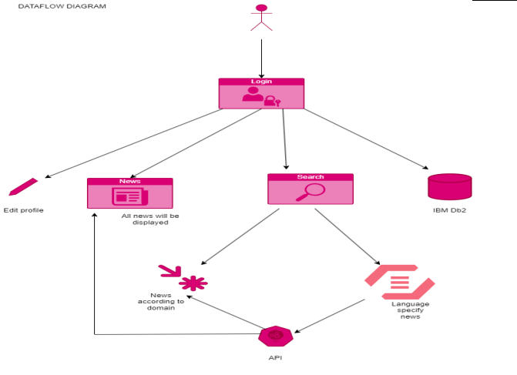

**5.2 Solution & Technical Architecture**

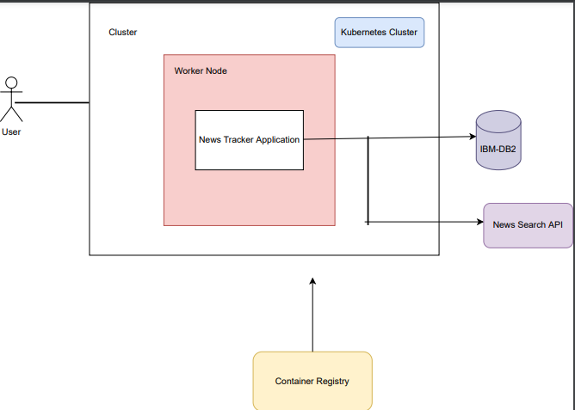

**5.3 User Stories**

|  |  |  |  |  |  |  |
| --- | --- | --- | --- | --- | --- | --- |
| **User Type** | **Functional Requirement (Epic)** | **User Story Number** | **User Story / Task** | **Acceptance criteria** | **Priority** | **Release** |
| **Customer (Mobile user)** | **Registration** | **USN-1** | **As a user, I can register for the application by entering my email, password, and confirming my password.** | **I can access my account / dashboard** | **High** | **Sprint-1** |
|  | **Login** | **USN-2** | **As a user, I can log into the application by entering email & password** | **I can access my account / dashboard** | **High** | **Sprint-1** |
|  | **All news feed displayed** | **USN-3** | **As a user, I can view all news** | **The user will see the most recent news that was fetched from the API.** | **High** | **Sprint-2** |
|  | **Filter Option** | **USN-4** | **The user can view news based on the filter options.** | **The user can filter the news based on their interests by using the filter option will be fetched and displayed** | **High** | **Sprint-3** |
|  | **Edit Profile** | **USN-5** | **As a user, I can edit my profile details** | **When necessary, the user may modify the information in their**  **profile** | **Medium** | **Sprint-2** |
|  | **Logout** | **USN-6** | **As a user,I can logout** | **User will be redirected to login page** | **High** | **Sprint-1** |

**6. PROJECT PLANNING & SCHEDULING**

**6.1 Sprint Planning & Estimation**

|  |  |  |  |  |  |  |
| --- | --- | --- | --- | --- | --- | --- |
| ***Sprint*** | ***Functional Requirement (Epic)*** | ***UserStory Number*** | **UserStory / Task** | ***Story Points*** | ***Priority*** | ***Team Members*** |
| **Sprint-1** | **Registration** | **USN-1** | **As a user, I can register for the application by entering my email, password, and confirming my password.** | **2** | **High** | **Anuharshini B**  **Samsitha Banu S**  **Charanya A G**  **Subashini B** |
| **Sprint-1** |  | **USN-2** | **As a user, I will receive confirmation email once I have registered for the application.** | **1** | **High** | **Anuharshini B**  **Samsitha Banu S**  **Charanya A G**  **Subashini B** |
| **Sprint-2** |  | **USN-3** | **As a user, I can register for the application through Facebook** | **2** | **Low** | **Anuharshini B**  **Samsitha Banu S**  **Charanya A G**  **Subashini B** |
| **Sprint-2** |  | **USN-4** | **As a user, I can register for the application through Gmail** | **2** | **Medium** | **Anuharshini B**  **Samsitha Banu S**  **Charanya A G**  **Subashini B** |

|  |  |  |  |  |  |  |
| --- | --- | --- | --- | --- | --- | --- |
| ***Sprint*** | ***Functional Requirement (Epic)*** | ***UserStory Number*** | **UserStory / Task** | ***Story Points*** | ***Priority*** | ***Team Members*** |
| **Sprint-2** | **Login** | **USN-5** | **As a user, I can log into the application by entering email & password** | **1** | **High** | **Anuharshini B**  **Samsitha Banu S**  **Charanya A G**  **Subashini B** |
| **Sprint-3** | **Dashboard** | **USN-6** | **As a user I should be able to navigate and access all the features hassle free** | **2** | **High** | **Anuharshini B**  **Samsitha Banu S**  **Charanya A G**  **Subashini B** |
| **Sprint-3** | **Layout** | **USN-7** | **As a user I should be able to access the portal with different devices with the same comfort** | **2** | **Medium** | **Anuharshini B**  **Samsitha Banu S**  **Charanya A G**  **Subashini B** |
| **Sprint-3** | **User Segregation and data access** | **USN-8** | **As a CC executive I should be able to uniquely identify the customer and offer help** | **1** | **Low** | **Anuharshini B**  **Samsitha Banu S**  **Charanya A G**  **Subashini B** |
| **Sprint-4** | **Change code** | **USN-9** | **As an administrator I should be able to modify code according to the future requirements.** | **2** | **High** | **Anuharshini B**  **Samsitha Banu S**  **Charanya A G**  **Subashini B** |
| **Sprint-4** | **Monitor the system** | **USN-10** | **As an administrator I should be able to monitor the cloud system and fix errors before customer.** | **2** | **Medium** | **Anuharshini B**  **Samsitha Banu S**  **Charanya A G**  **Subashini B** |

**6.2 Sprint Delivery Schedule**

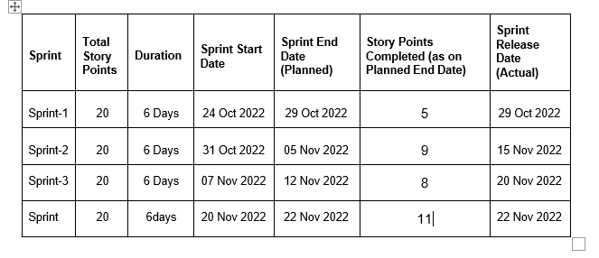

**6.2 REPORT FROM JIRA**

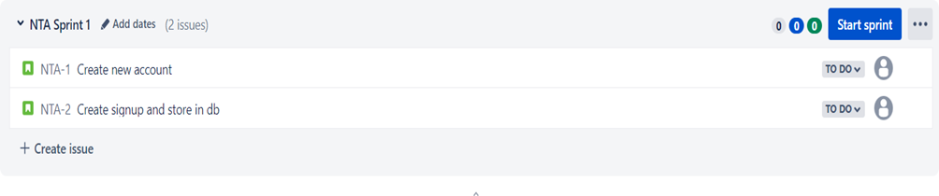

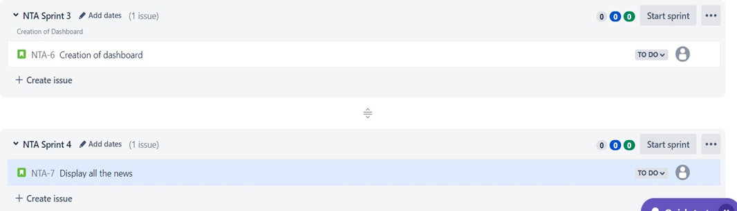

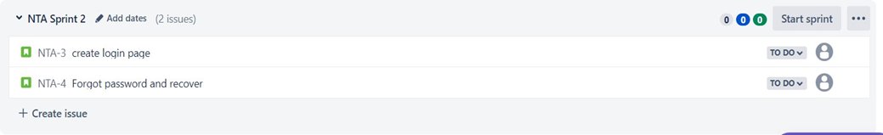

**7.** **CODING & SOLUTIONING**

**7.1.** **Signup/Registration**

**External users can create new user accounts using the news tracker application's registration feature. The importance of registration is great because a user can only log in and access the functionalities if they have registered.**

## **Signup.html**

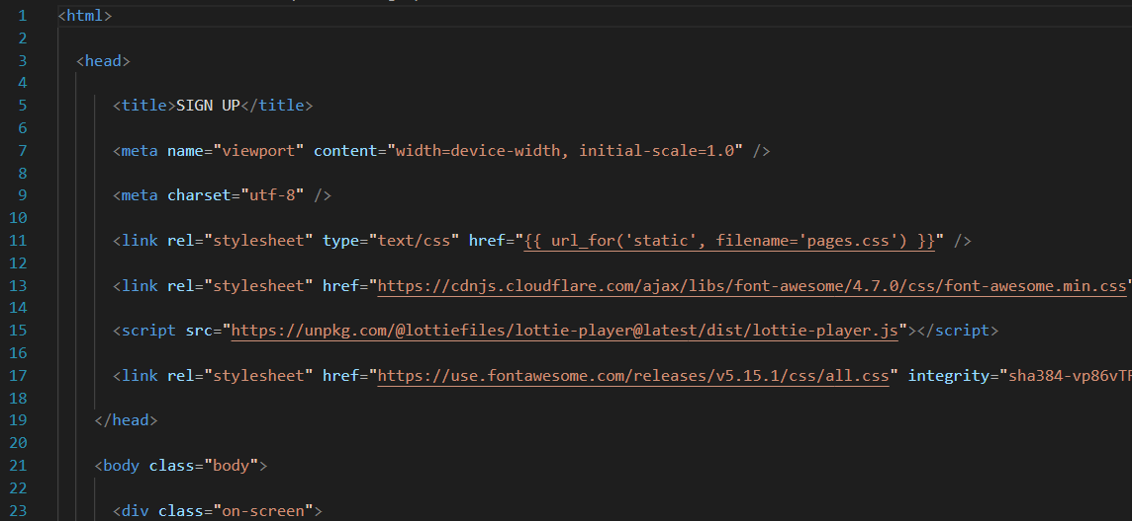

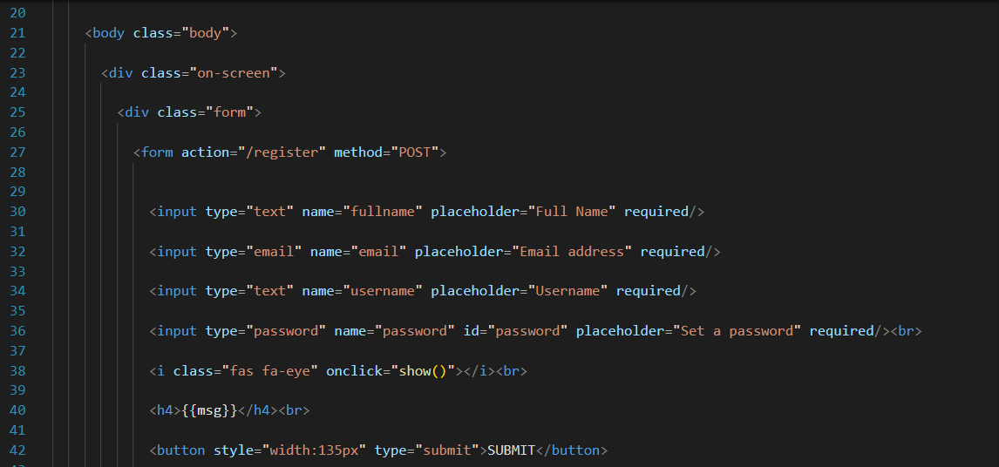

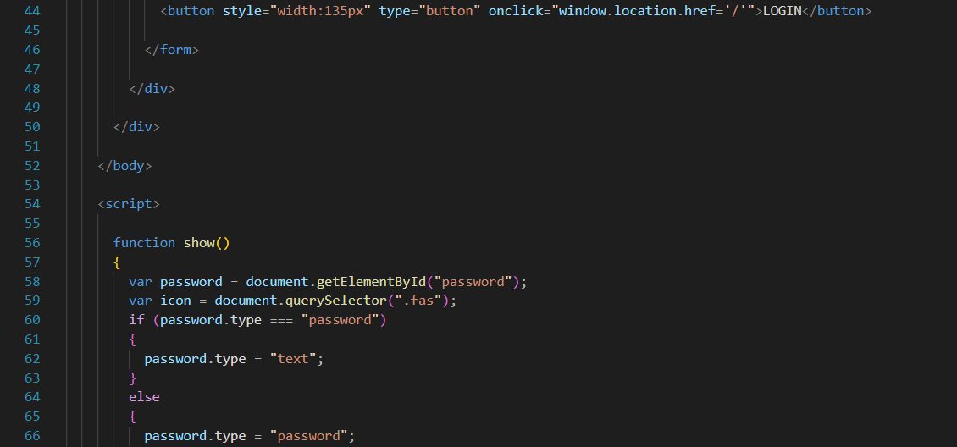

## **7.2.Login:**

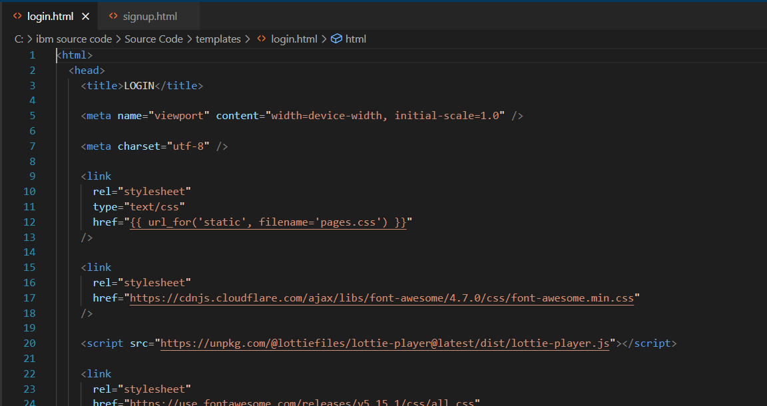

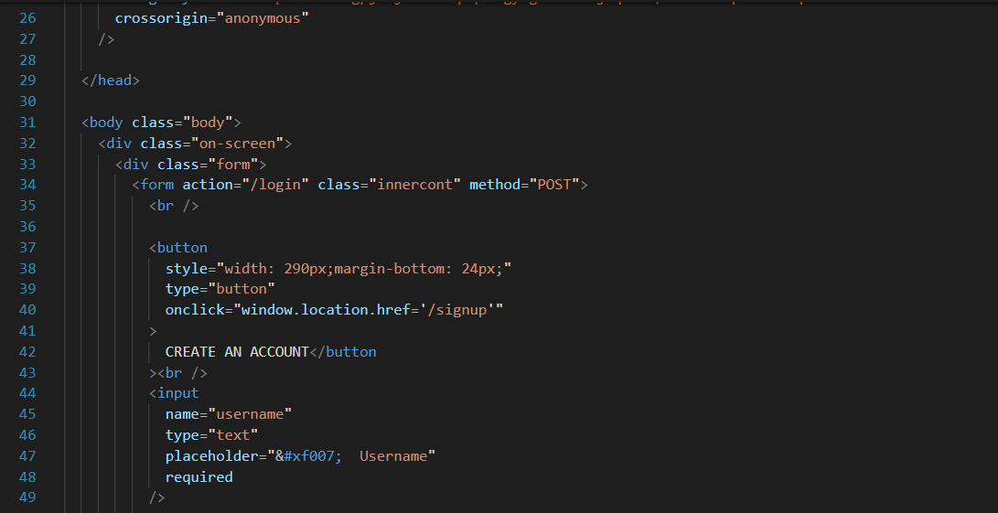

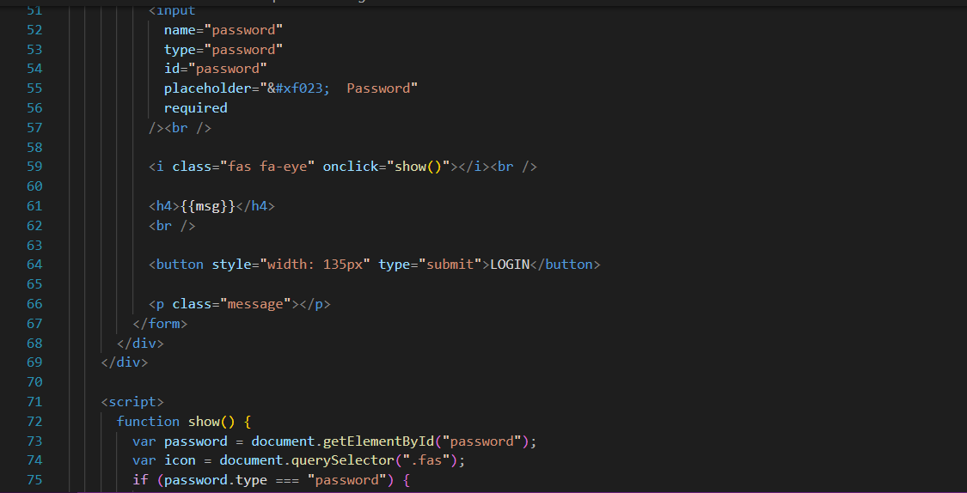

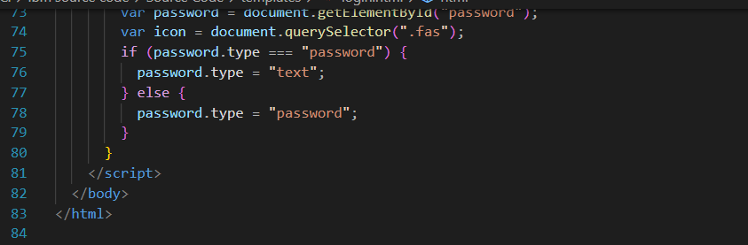

**7.3. Dashboard:**

All of the well-known news station names will be displayed on the dashboard feature. The user may select from based on their preferences. When they click, they will be taken to the relevant news channel's news.

## **dashboard.html**

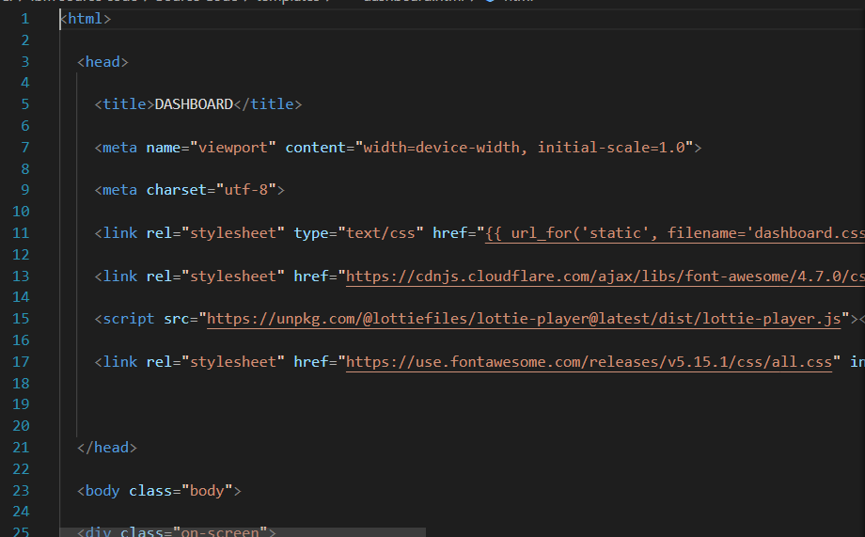

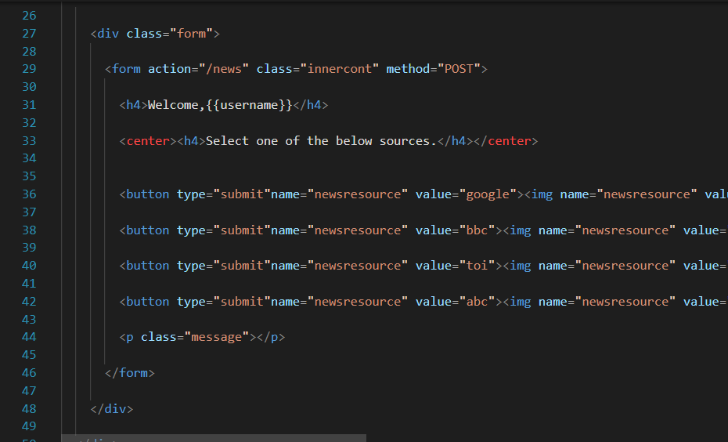

# **7.4. Logout**

This feature allows customers to log out of his/her account.

7.5. Database Schema

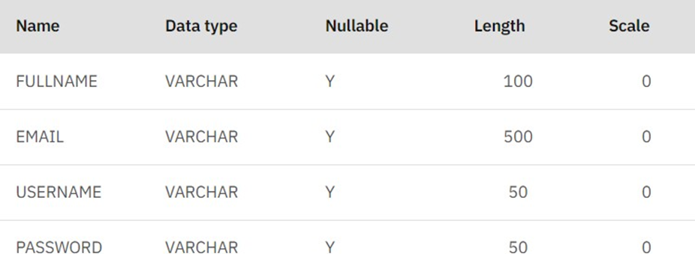

**8.TESTING**

**8.1.Test cases**

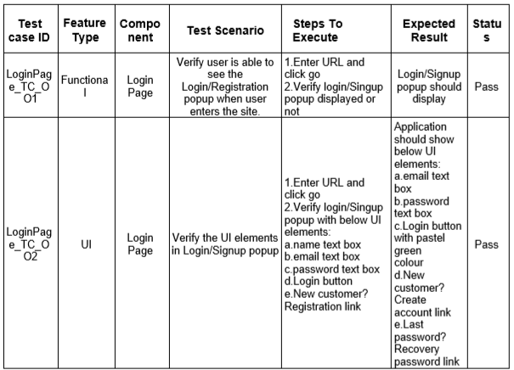

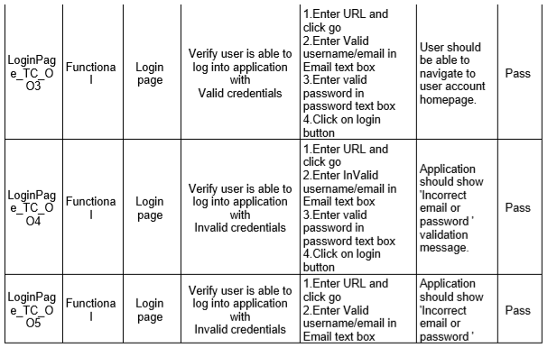

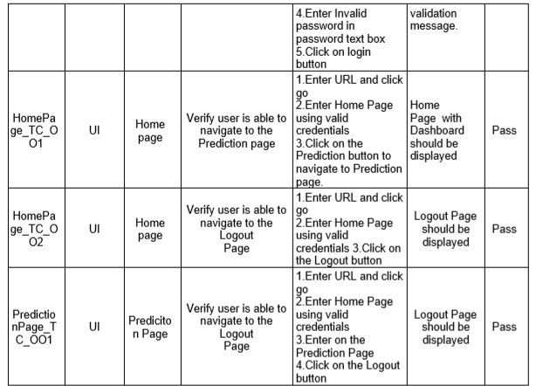

**8.2.** **User Acceptance Testing**

## **Defect Analysis**

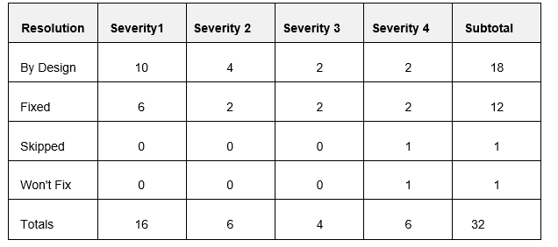

**Test case Analysis**

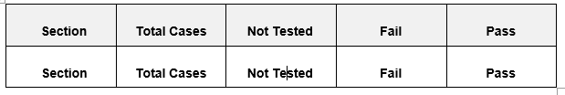

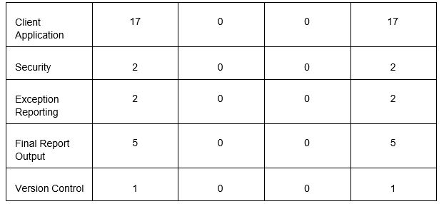

**10. ADVANTAGES & DISADVANTAGES**

**Advantages:-**

* News is already organized in this app.
* Accessible and transportable.
* improved client experience.
* Apps can help you turn casual readers into devoted ones.
* News updates on a minute-by-minute basis.
* You can use this app to rapidly receive local news updates.
* To research and identify hot topics and news.
* Personalized news feeds based on your interests.

**Disadvantages:-**

* Some apps need a user to subscribe to a premium version.
* When advertisements appear, they disrupt users.
* The news occasionally provides succinct information.
* The prevalence of false and ambiguous news might mislead users and cause confusion.
* Readers may be misled by fake news.

**11.Conclusion:**

We examined the viability of identifying interaction patterns in reading news and assessed three adaptive interface designs for various news reader categories. We demonstrate how a specific user can be identified as one of three types based on their interaction record. The online survey revealed several different and well-defined reader types. Different news reader types require various user interfaces, according to the examination of the three variation interfaces. We have shown how to track users' news reading habits and determine their news reader type from it. In order to be able to present a complete adaptive mobile news framework that provides automatic personalization of news apps, we will continue to investigate the design of adaptive interfaces in the future.

**12.Future Scope:**

In the future we will further explore the design of adaptive interfaces, in order to be in a position to demonstrate a complete adaptive mobile news framework providing automatic personalisation of news apps.

**13.Appendix:**

**Source code:**

**Source code is uploaded in the GitHub:**

**https://github.com/IBM-EPBL/IBM-Project-13292-1659515995**

**PROJECT DEMO LINK:**

**https://drive.google.com/file/d/1U8E1d-zoh0tEdAzp_e-g6uS1X8YGbE8g/view**